Assignment-4

|  |  |
| --- | --- |
| Team ID | PNT2022TMID02938 |
| Project Name | Nutrition assistant application |

1. Pull an image from docker hub and run it in the docker playground.

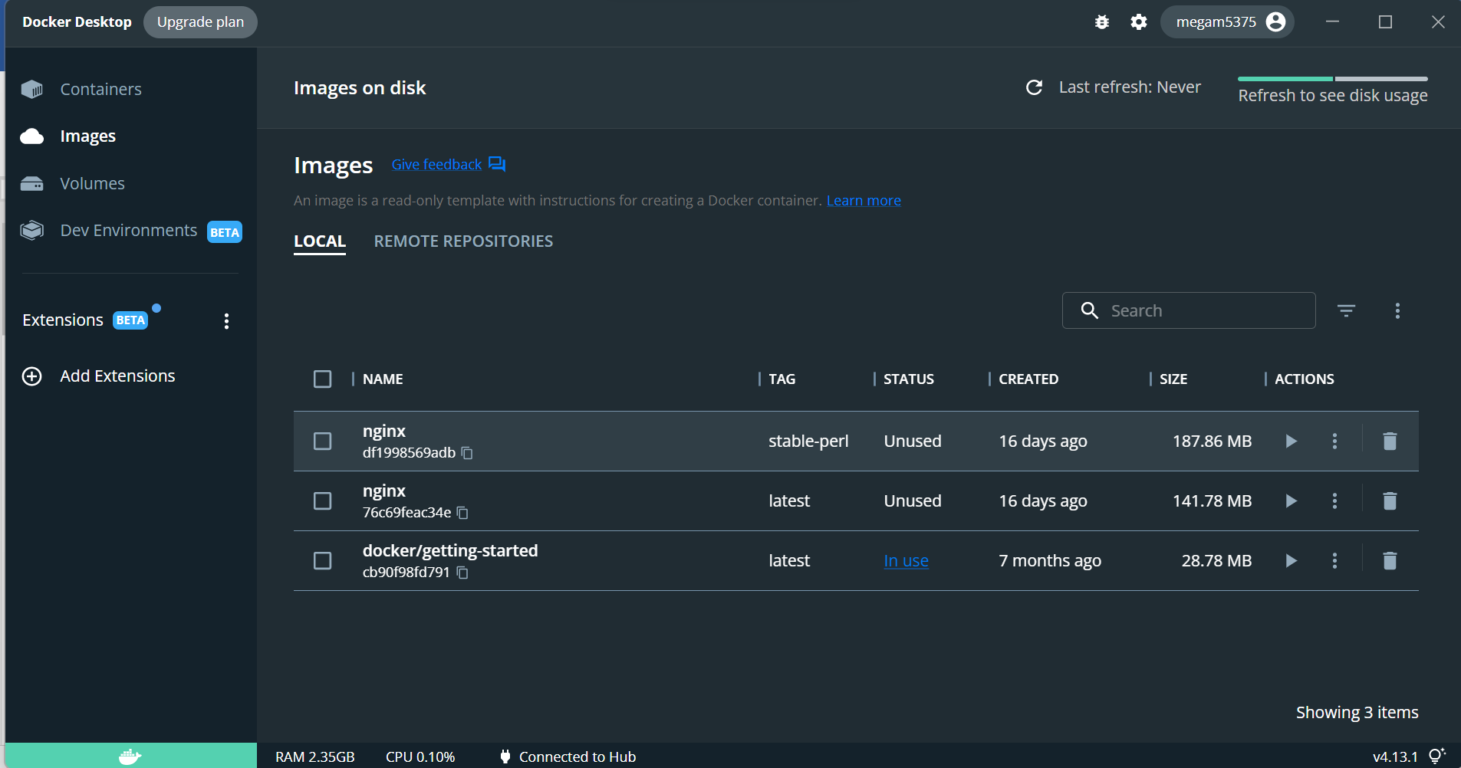

1. Create a docker file for the jobportal application and deploy it in the docker desktop

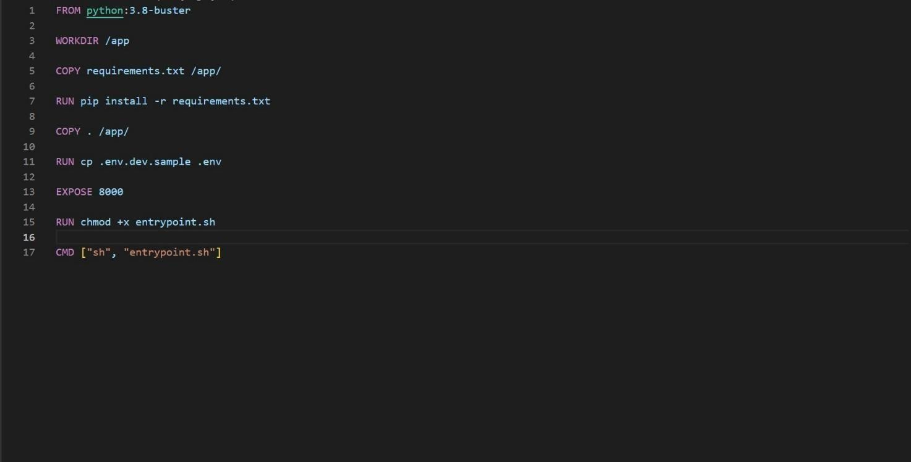 application

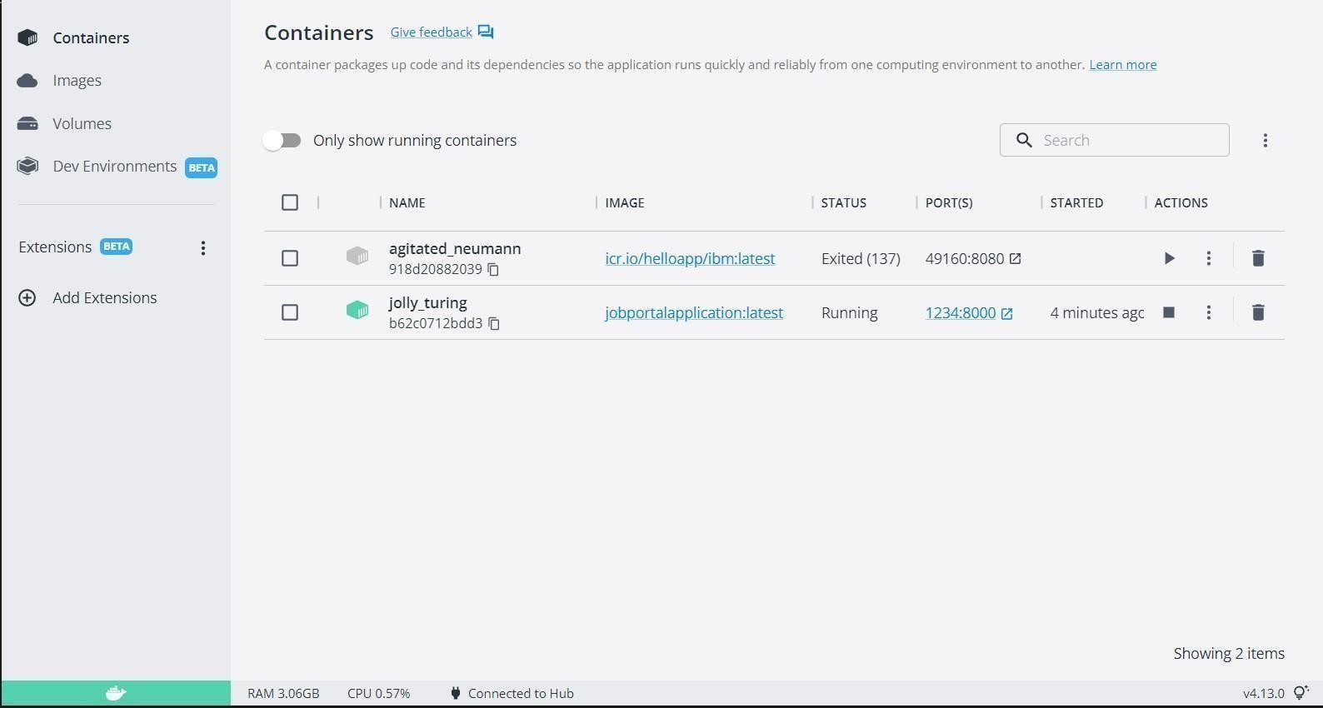

1. Create a IBM container registry and deploy helloworld app or jobportapp.

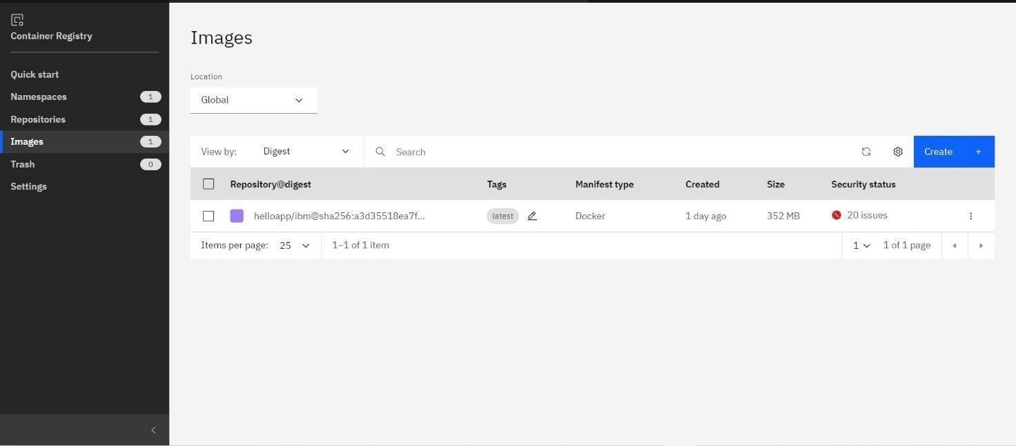



1. Create a Kubernetes cluster in IBM cloud and deploy helloworld image or jobportal image and also expose the same app to run in nodeport.

